Multi-Player Collaborative Game-Work Maker

*Dynamic Difficulty Adjustment with Reinforcement Learning and Natural Language Processing*

1. **Game Scenario**

|  |  |  |  |  |  |  |  |
| --- | --- | --- | --- | --- | --- | --- | --- |
| One Trajectory | | | | | | | |
| Difficulty 1 | | Difficulty 2 | | Difficulty 3 | | Difficulty 4 | |
| Test 1 | Study 1 | Test 1 | Study 1 | Test 1 | Study 1 | Test 1 | Study 1 |

图示

1. **Difficulty Definition**

|  |  |  |  |  |
| --- | --- | --- | --- | --- |
|  | Attempts | Chinese | Phonetic | Time(S) |
| Difficulty 1 | 3 | Yes | Yes | 60 |
| Difficulty 2 | 2 | Yes | Yes | 40 |
| Difficulty 3 | 1 | Yes | No | 30 |
| Difficulty 4 | 1 | No | Yes | 30 |

As we can see from the above picture, one trajectory includes four rounds. The difficulty level increased with the game round goes. According to the difficulty definition, students have good retention if they are able to correctly spell the word in an imperfect information context.

**Question 1: Why do I provide letters?**

Answer 1: Students can practice more words in one classroom session (40 minutes) than without letters. Given the English syllabus's requirements and time, it is insufficient to remember required words if the game does not provide letters.

**Question 2: Why do I Design the game like this?**

**Answer 2:** I implemented four learning theories: (1) intentional learning, (2) trial and error, (3) repetition, and (4) Test Effects, all of which can facilitate the retention of vocabulary. **Intentional learning:** The game directly provides all the information students need to finish the task, which can save time; (2) **trial and error**, students get several attempts to finish the task and constantly learn from errors. (3) **Repetition**. Students will encounter the same word many times in one trajectory. (4) **Test Effects.** The combination of the test-study model is more effective than the repeated study. Additionally, as the game goes from difficulty one to difficulty four, it can both enforce short-term (perfect information) and long-term memory (imperfect information).

**Conclusion:** I have conducted the empirical experiment with Word Maker. It found that the Word Maker is efficient enough to be implemented in classrooms. However, it also found that students feel bored and time-wasting when they play easy words four times, while students feel stressed and frustrated when they play hard words within the limits of attempts and imperfect information. **It is a problem that the game cannot dynamically provide an appropriate difficulty level according to the student’s English proficiency, which is also the research gap in the Educational Video Games field.**

1. **Dynamic Difficulty Adjustment**

As we discussed before, the game could be a multi-player collaborative game, and it would be helpful if I can implement the game into the open-spiel framework. However, as I deep dive into the open-spiel, I found that my game is not suitable for the open-spiel framework because (1) All my agents do not share the same action space, and the action per agent is private and fixed, (2) my game is not strictly a sequence-based game, consequently, the next player is uncertain. Therefore, you suggested that we start to build the agent interface, state interface, and environment interface by simulating the open-spiel framework, all of which had been finished by the end of 14 June 2023 (from the start of June). I just finished one trajectory of the game by using the build interfaces. I will describe in detail for you to understand the whole process.

To simulate the game with dynamic difficulty adjustments, there are three things we need to do. (1) simulate the student with different English proficiency, (2) simulate the process of student playing the game, (3) the tutor agent dynamically provides a difficulty level according to the observation (game state) before the game moves to the next round (4 rounds in total). Let us go through step by step.

1. **Simulate Student**

In the real classroom, students learn the vocabulary by using the vocabulary list of textbooks. The vocabulary list provides the Chinese, phonetic and counterpart English spelling (See the picture below). Additionally, the vocabulary can be categorized into **known words** and **unknown words** for a real student. Therefore, the first step is to create the virtual students with Known words and unknown words.

* + 1. **Download CET 4 Vocabulary List**

CET 4 is the English examination every undergraduate student must pass, otherwise, they cannot get the graduation qualification. There are around 4500 words in the vocabulary list.

* + 1. **Preprocess Vocabulary List**

For simplify, I extract one of Chinese meanings (there are many), phonetic, and counterpart English spelling, and stored them in two files (1): the source file consists of Chinese and Phonetics, (2) the target file consists of English words. The contents of each file see below:

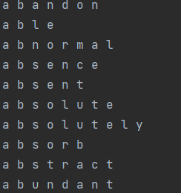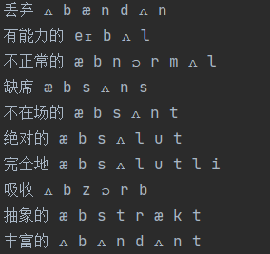

In this way, it can roughly but similarly simulate a real student’s situation when they remember vocabulary. Also, it is in line with my game environment, where students finish the task according to the provided chinses and phonetics. **How do we use the processed vocabulary list?** **My assumption**: if one model performed well on the training data and performed badly in the testing data, which means the students’ remembered the words in the training data and do not know the words in the testing data. In this way, we can create the virtual students with **Known words** and **unknown words.** Additionally,the size of the training data represents the students’ vocabulary size. Let us go the next step.

* + 1. **Formulate NLP Model.**

The purpose of the NLP model is to achieve **the assumption I mentioned above**. The definition of known words is NLP model can give the correct spelling (training data) based on the Chinese and Phonetic, while the definition of unknown words is NLP model cannot give the correct spelling (testing data). I used **accuracy, completeness, and perfect spelling** to evaluate the model:

1. **Accuracy:** virtual student spelling: ‘helll’, real answer: ‘hello’. So, the accuracy is 80%.
2. **Completeness = 1- minimum edits/maximum edits:** virtual student spelling: ‘helll’, real answer: ‘hello’. So, the completeness is 80%. In the example, it will be 1-1/5 = 0.8
3. **Perfect Spelling:** virtual student spelling: ‘helll’, real answer: ‘hello’. Incorrect spelling gets zero point, while correct spelling gets one point.

**The split rate means** the ratio of the whole vocabulary list (around 4500), which is the size of training data (students with different vocabulary proficiency).

**I spend the whole of May to build the NLP model and achieved our assumption.**

|  |  |  |  |  |  |  |
| --- | --- | --- | --- | --- | --- | --- |
| **Split Rate (Train-Test)** | **Accuracy** | | **Completeness** | | **Perfect** | |
|  | **Train** | **Test** | **Train** | **Test** | **Train** | **Test** |
| **0.1** | 99.9% | 27.6% | 99.9% | 14.9% | 99.2% | 0.00 |
| **0.2** | 99.5% | 34.4% | 99.5% | 21.8% | 97.4% | 0.00 |
| **0.3** | 99.4% | 34.6% | 99.4% | 24% | 97.0% | 0.00 |
| **0.4** | 99.2% | 35.3% | 99.2% | 25.5% | 96.3% | 2.2% |
| **0.5** | 99.2% | 33.1% | 99.1% | 15.2% | 96.1% | 0.00 |
| **0.6** | 99.4% | 36.5% | 99.4% | 26.4% | 96.5% | 0.00 |
| **0.7** | 99.2% | 42.3% | 99.2% | 34.9% | 96.3% | 0.00 |

From the above table, we can see that (1) The metrics training data are above 95%, which means that students know these words, and (2) the accuracy and completeness of testing data are below 40%, which means students do not know these words. Also, the perfect spelling is nearly 0, which means virtual students cannot correctly spell the words (unknown words). By now, we create seven levels of virtual students with different vocabulary proficiency.

**All the code and data are available at github link:** [**https://github.com/SryMkr/education_game_RL/tree/main/open_spiel_code/NLP**](https://github.com/SryMkr/education_game_RL/tree/main/open_spiel_code/NLP)

* 1. **Simulate the process of student playing the game.**

The picture below shows the process of the game.

1. Chance Agent randomly select a task from the task pool (highlighted in yellow).
2. Tutor agent decided the difficulty level (highlighted in green).
3. Student agents finish the task (highlighted in blue).
4. Examiner agents give students feedback to improve their spelling and tutor feedback to decide difficulty level.

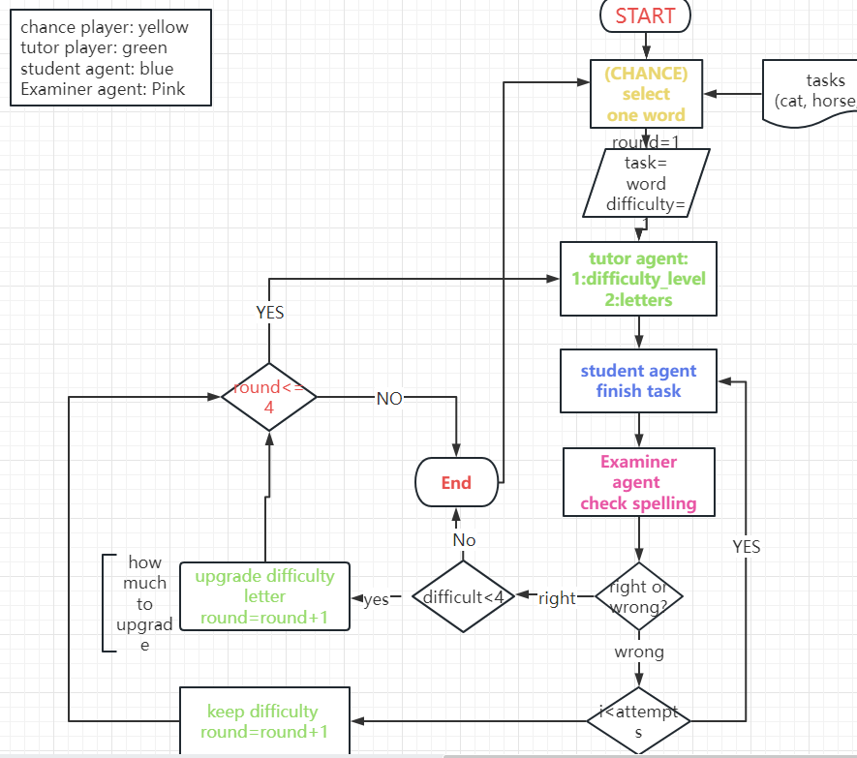

* + 1. **Formulate agent interface, state interface, environment interface.**

(1): I formulate the agent interface. The Chance agent to select task, Tutor agent to decide difficulty level, Student Agent give spelling, and Examiner agent to give feedback. The agent interface is available at github link: <https://github.com/SryMkr/education_game_RL/blob/main/open_spiel_code/Word_Maker_Interface/agents_interface.py>, and the agent instance is available at link: <https://github.com/SryMkr/education_game_RL/blob/main/open_spiel_code/Word_Maker_Interface/agents_instance.py>

(2): The state interface is available at github link: <https://github.com/SryMkr/education_game_RL/blob/main/open_spiel_code/Word_Maker_Interface/state_interface.py>

the state instance is available at github link: <https://github.com/SryMkr/education_game_RL/blob/main/open_spiel_code/Word_Maker_Interface/word_maker_state.py>

(3): The environment interface is available at github link: <https://github.com/SryMkr/education_game_RL/blob/main/open_spiel_code/Word_Maker_Interface/environment_interface.py>

The environment instance is available at github link:

<https://github.com/SryMkr/education_game_RL/blob/main/open_spiel_code/Word_Maker_Interface/word_maker_environment.py>

* + 1. **Finish one trajectory.**

1. Chance Agent randomly select a task. Only act once at the start of the game.
2. Tutor agent decides difficulty level. Currently, the difficulty level is the same as the game round. Act when the round changes, therefore, act four times in the four-round game.
3. Virtual students give spelling (the NLP model) according to the information provided (Chinese and/or Phonetic). Action numbers are based on the limitation of total attempts and accuracy. After each round (four rounds in total), the virtual students need to remember new knowledge (train NLP model).
4. Examiner give both student feedback and tutor feedback. Students feedback is for student’s agent to improve their spelling after one attempt. Tutor feedback (accuracy, completeness, attempts, difficulty level, …) is for tutor to decide the difficulty level of next round.
5. Loop until game reach the round four.

The hard parts are (1) the students give legal spelling according to the available letter, (2) agents interact in one trajectory, and (3) implementing the training process in the middle of the game (simulating the student learn from history and challenge the hardest difficulty level). I was working on the three problems in the past two weeks. The next part will use the RL algorithm (tutor agent) to dynamically adjust the difficulty level according to the observation (tutor feedback from examiner agent).

1. **Simulate Tutor Agent with RL**

**I learned the RL algorithm in the whole of March to prepare this part. I prepared well to continue…..**

**1：假如我有一个4000个单词的，各种不同的学生，以及各种不同的tutor agent，各自需要多少时间以及准确率**

**2：学生的类型：可以是 我看音标来记忆单词，有的是看汉语，有的是forgetting，有的可以完全记住， n gram**

**3：老师的类型是： 随机给单词，按照学生的表现选择单词以及给难度，或者使用spaced repetition**

Learning Vocabulary

*Multi-Player Collaborative Game*

1. **Vocabulary Apps**

From 26/06/2023-02/07/2023, I played 8 different and popular vocabulary learning apps, including 4 apps prevailing in China, and another 4 in foreign countries. I will describe them in detail and explore how they work.

1. **Bai Ci Zhan**



**1: Vocabulary Books.** The app prepares many categorized vocabulary books in line with the English syllabus and educational levels. Students need to select one that they are interested to learn.

**In the framework design,** it should be one of the functions in **Utils directory** that including the commonly used functions, classes, configuration files, or other auxiliary modules to provide general-purpose features and tool support. Researchers simply **provide** the name of vocabulary book, and what information they want use; the function **returns** the fixed format of information. Also, I need to pare some test data.

2: **All possible Information:** (1) English word; (2) part of speech; (3) picture; (4) phonetic; (5) sentence; (6) counterpart Chinese.

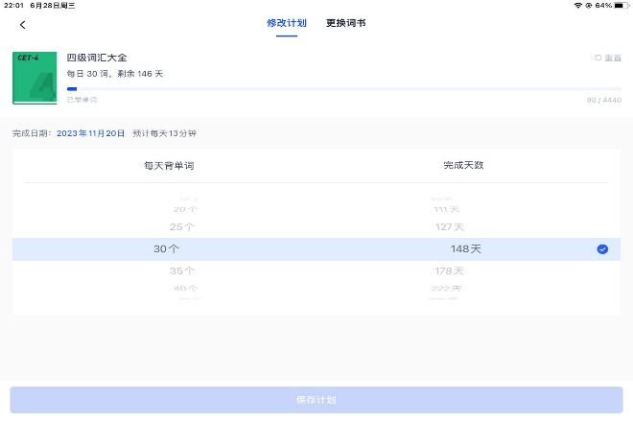

**2: Setting.** Students set the number of task words (range (5,1000,5)) in one session. In this app, the student is unaware of what words will be learned in the current session.

**In the framework design**, it should be one of the functions in the Utils directory. There are four optional selection methods, including random, sequence, spaced repetition (learn + review), and forgetting curve (learn + review).

**3:** **Game** **Functions:** (1) kill current word if student already known; (2) provide more information if student made mistakes (sentence, English explanation, Chinese, all information in order); (3) audio pronunciation

**Difficulty one:** Select the correct picture based on the given sentence along with the speaking of sentence (see below left picture).

**Difficulty two:** select the correct Chinese based on the given information (English word, phonetic, part of speech, Chinese, pronunciation) (see below middle picture).

**Difficulty three:** select the correct Chinese based on the given information (English word, phonetic, pronunciation) (see below right picture). the combination of one picture, Chinese, phonetic, part of speech (perfect information).

**4: In one session:**

* **learning target:** select the correct answer in difficulty three.
* **Learned definition:** Correctly answer all difficulty levels.
* **More information:** provide more information if student made mistakes (sentence, English explanation, Chinese, all information in order), which mean decrease the difficulty level.
* 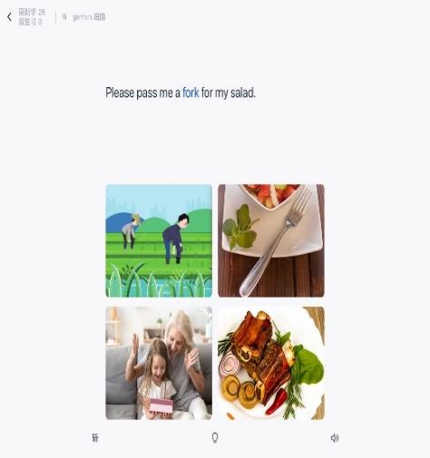**Leitner System**

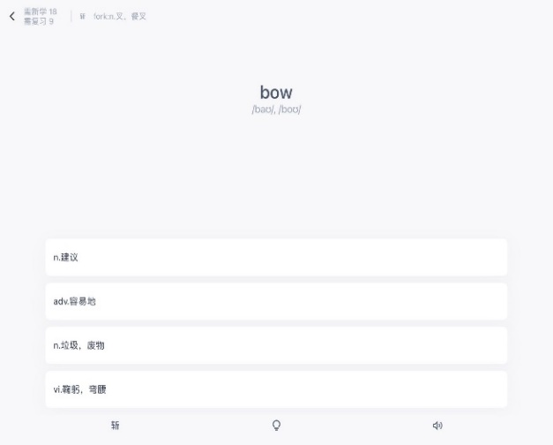

**5: Test Methods:**

1. **表格

**Select correct Chinese.
2. Select correct English.

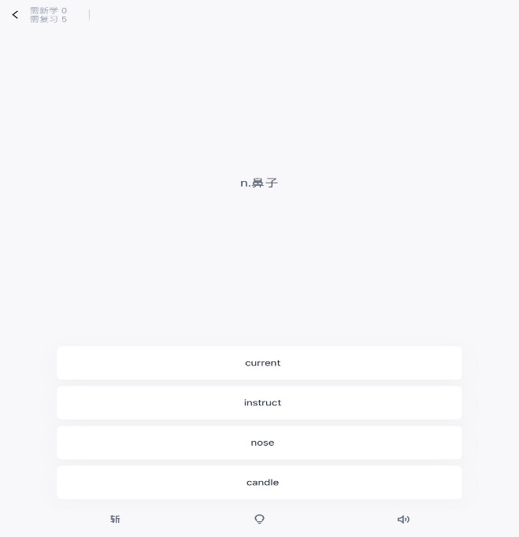

1. Spelling with Given Letter

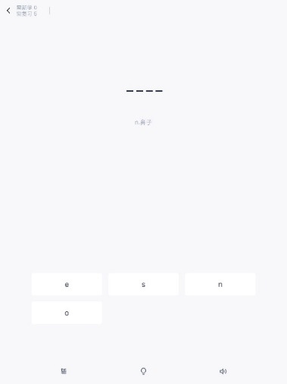

1. 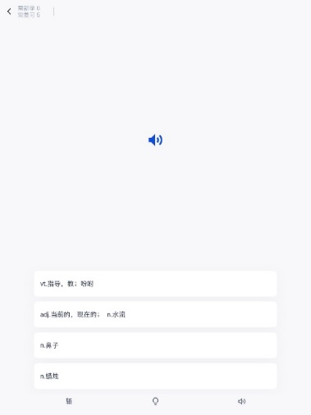Spelling with given pronunciation
2. Fill the blank

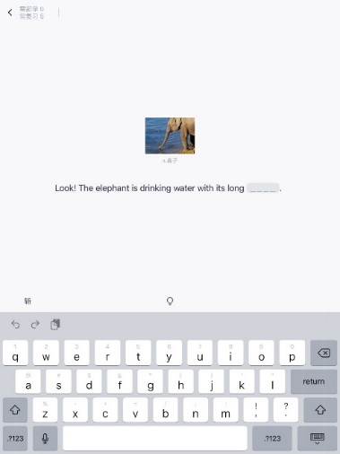

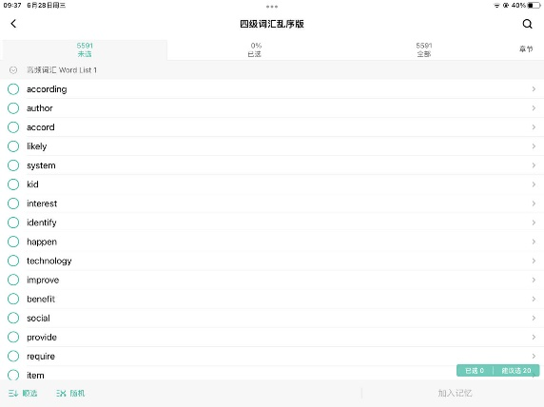**MO MO**

1: **Choose book.** there are lots of vocabulary books. Students need to select one of the books. 按照教科书，考研，四级六级等等进行分类，学生需要选择一本书学习.

2: **Setting:** set the numbers of words per day. Suggest 20. 有三种选择方式: 1: 学生自己选择, 2: 顺序选择, 3: 随机选择

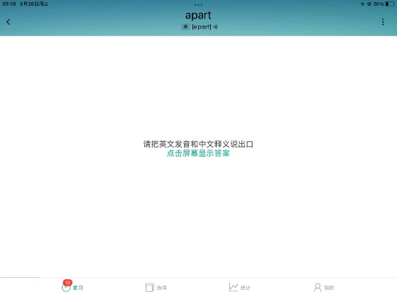 3: **Learn:** speak out the pronunciation and Chinese based on the English and phonetic.

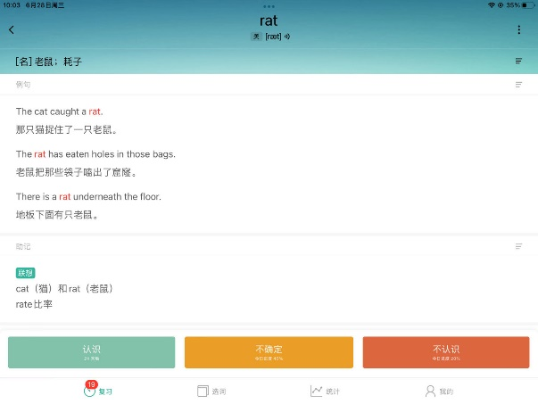4: **Information:** (1) part of speech; (2) Chinese; (3) English; (4) sentence; (5) phonetic

**5: Choose memory level:** (1) known, (2) uncertain, (3) unknown

**6: In one session:** (1) 所有的单词都需要一遍遍得学习, 如果选择了不知道或者不确定会重复出现直到点击了认识, (2) 使用了遗忘曲线(The Ebbinghaus forgetting curve)理论, 也就是说每隔一段时间需要复习的单词会加入学习计划, 解决了新单词和学过的单词之间选择的问题. (3) 观察下一天的单词是什么? (4): 统计遗忘曲线也需要学生长时间的使用软件.

1. **Bu Bei Dan Ci**

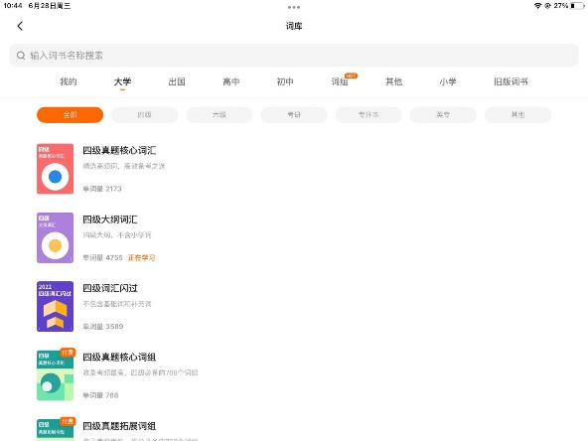

1: **Choose book.** there are lots of vocabulary books. Students need to select one of the books. 按照教科书，考研，四级六级等等进行分类，学生需要选择一本书学习.

2: **Setting:** set the numbers of words per day. Suggested 10.

3: **Learn:** select the correct Chinese based on the English word.

**4: Information:** (1) part of speech; (2) Chinese; (3) English; (4) sentence; (5) phonetic

**5: Spelling:** spell the word after immediate learning

**6: In one session: 也是选错的单词会一直选择，直到答完所有的单词，学会的就不需要学, 学习目标是一轮学习学会所有的单词.**

1. **Shan Bei**

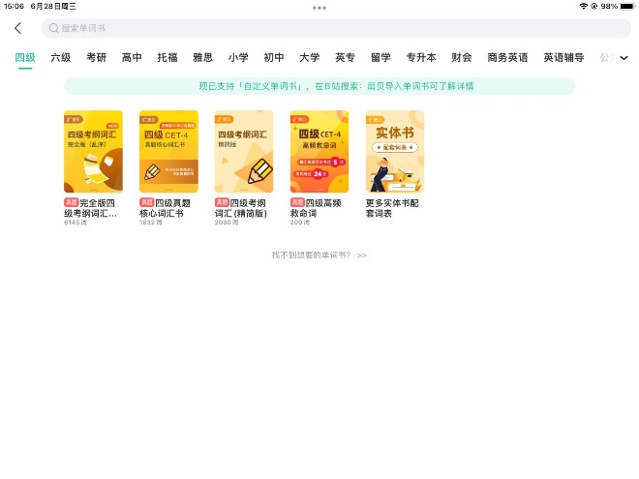

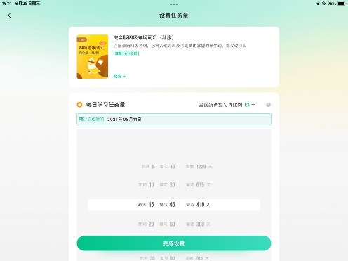1: **Choose book.** there are lots of vocabulary books. Students need to select one of the books. 按照教科书，考研，四级六级等等进行分类，学生需要选择一本书学习.

**2: Setting:** set the numbers of words per day. Range from 5-200 per day. The ratio of unknown and known words is 1:3.

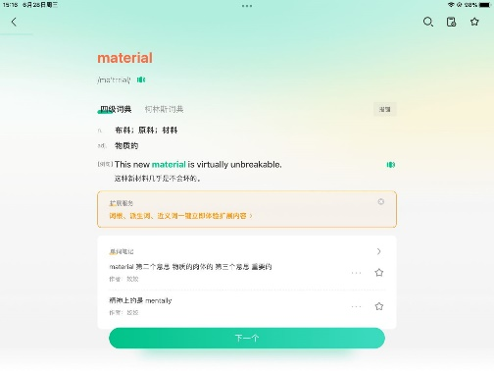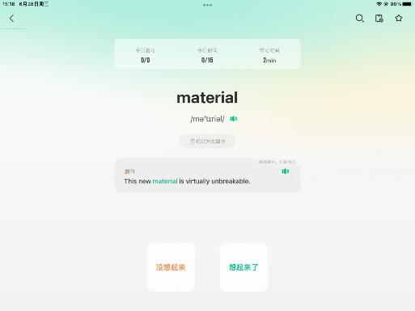

3: **Learn:** Recall the Chinese based on the given English and phonetic, if click yellow button, the picture will give the sentence, and if continue to click yellow button, the picture will give the total information.

4: **Information:** (1) part of speech; (2) Chinese; (3) English; (4) sentence; (5) phonetic

**5: In one session: 如果一开始选择不认识则代表没学会，会隔几个单词在展示一次，直到所有的单词都选择了认识，学会的就不需要学, 学习目标是一轮学习学会所有的单词. 每隔5隔单词会有单词小结，展示所有的信息让学生复习。学习完单词以后会出一篇短文供学生复习。**

**6：test: 有和百词斩一样的测试，包括英选中，中选英，根据发音想意思，以及根据中文拼写单词。**

1. 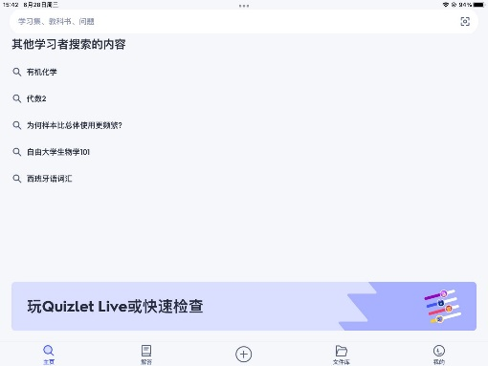**QuizLet: 付费产品，且以flashcard的方式进行学习**

1: **Choose vocabulary topics.** there are lots of vocabulary category. Students need to select one of the categories. 按照学科进行分类，而不是年级.

2: **Setting:** set the numbers of words per day. Suggest 10

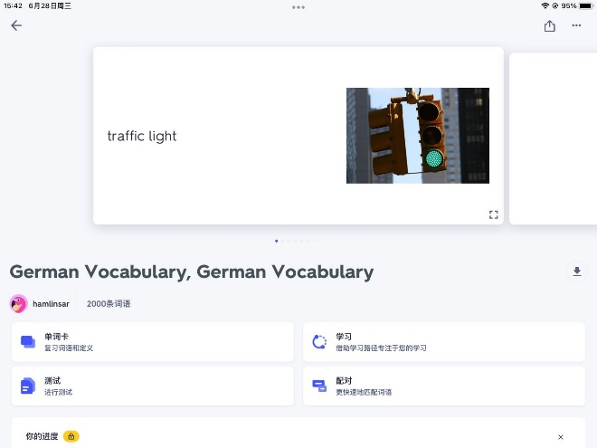3: Learn: recall the counterpart English based on the target language.

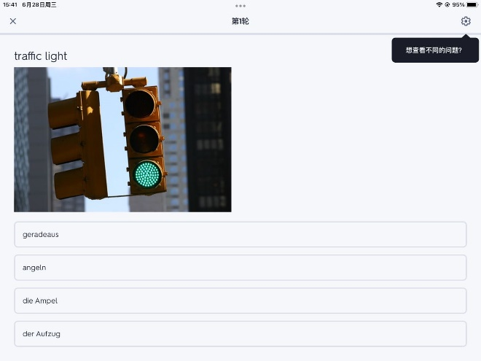 **4: information: (1) picture; (2) pronunciation; (3) target language**

**5: test: multiple-choice questions**

1. **Memrise**

1: **Choose vocabulary topics.** there are lots of vocabulary category. Students need to select one of the categories.

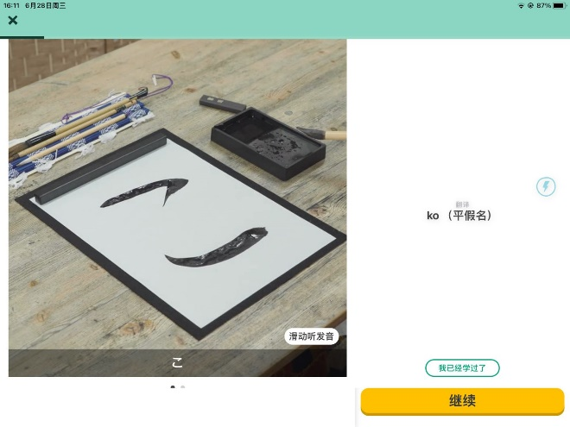2: **Setting:** set the numbers of words per day. Suggest 5, 10, 15

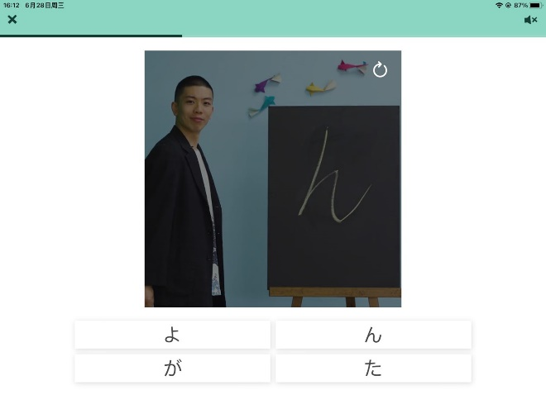3: Learn: 根据视频学习单词

4: test: multi-choice questions.

1. **Anki**

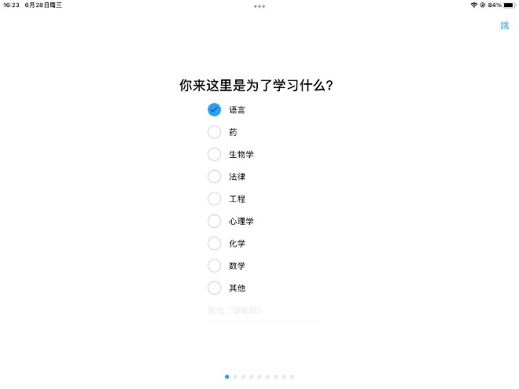

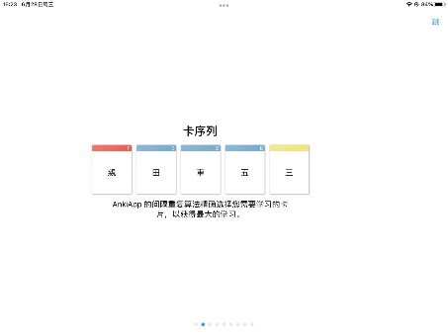1: **Choose learning topics.** there are lots of vocabulary category. Students need to select one of the categories.

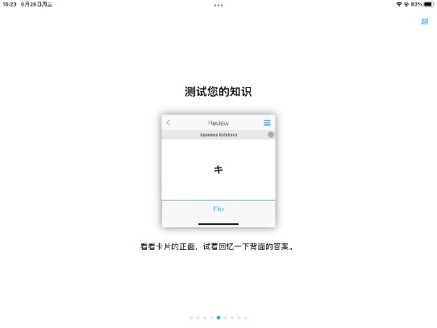2: Spaced repetition: 使用间隔学习方法，理论上也是有一个遗忘曲线

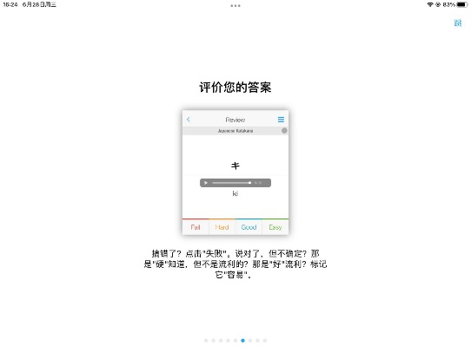3: Learn: Flash card

4: Choose the difficulty level. 选择困难的难度来决定多少天复习一次。由学生来决定难度

1. Duolingo

1: there is the fixed learning topic in each session.

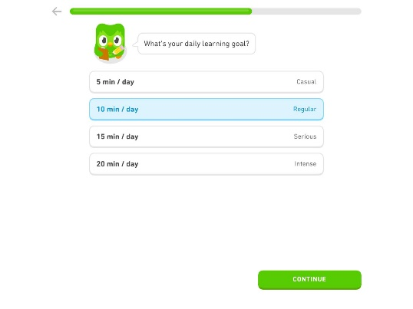2: setting: set the learning time per day, around 5-10 words in one session.

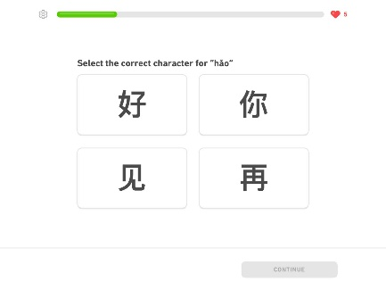3: Learning Method: Multi choice questions, Matching,

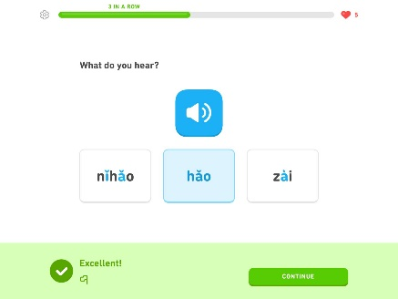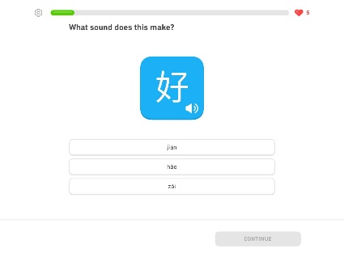

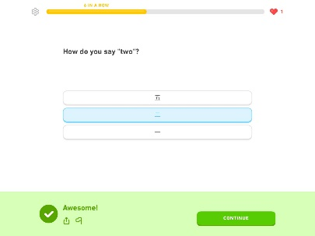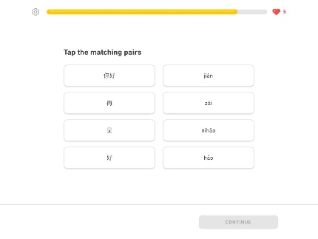

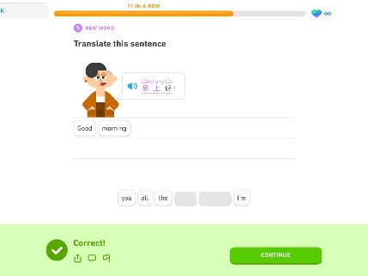

4: **In one session:** play the same batch of word in one session many times via above level. There is an underline algorithm to decide the difficulty of content, 说白了就是课程安排. 但是我们的英语课已经设定好了学习难度，所以理论上来说我们的英语课就是已经安排好了慢慢学习，多邻国所作的事情被我们英语课程安排好了.玩几天让我看看到底有上面魔法让simon如此着迷。

5: **information: (1) picture; (2) pronunciation; (3) target language**

**6：（1）是不是不同的学习形式代表了学习难度，那么他们是如何决定某个词语下一次的学习难度应该是什么？答对了下一次增加难度，答错了下一次降低难度呗。打错了给反馈，也就什么都没有了。**

**（2）：至于学习内容就是已经安排好的，每次课程也没学习了几个单词。**

**Question one:** Student Agent Interface: Student agent need to give a spelling based on vocabulary information, therefore, what kinds of information do we provide as the input of the student agent interface?

**Opinions: (1) Picture, (2) Chinese, (3) phonetic, (4) pronunciation, (5) part of speech, (6) available letter, (7)**

What do you mean the different student agent?

首先第一 到底选择什么单词是系统决定的么？

第二： chance player 按照单词的难度来来决定下一个展示什么单词

第三：老师根据提供的单词决定提供什么样的难度关卡

第四，单词难不难首先根据长度，其次根据examiner的反馈信息也就是学生表现